DAA Lab Programs 1 to 10

- Find the First Palindromic String

Aim: To find the first string in an array that reads the same forward and backward.

Pseudocode:
- Start.
- Read the list of strings.
- Check each string by comparing it with its reverse.
- If they are equal, print that string and stop.
- If no palindrome is found, print an empty string.
- Stop.
Code:

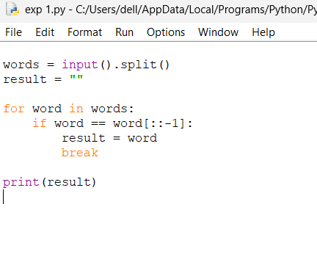
Output:
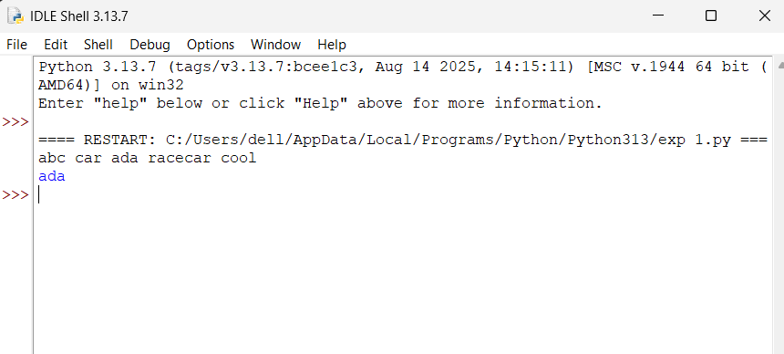

Complexity:
- Time: \(O(nL)\), where \(n\) is the number of strings and \(L\) is the maximum string length.
- Space: \(O(L)\) for reversing a string.

- Count Common Elements in Two Arrays

Aim: To count how many elements in each array also appear in the other array, counting repeated occurrences.

Pseudocode:
- Start.
- Read arrays nums1 and nums2.
- Count elements of nums1 that occur in nums2.
- Count elements of nums2 that occur in nums1.
- Print both counts as a list.
- Stop.
CODE:
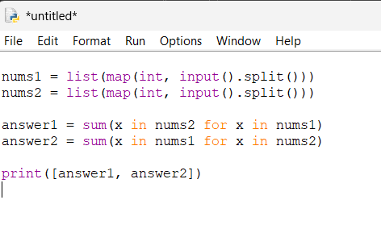
Output:

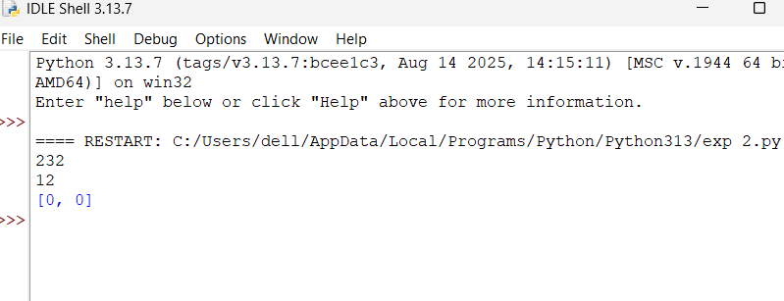

Complexity:
- Time: \(O(nm)\), where \(n\) and \(m\) are the array lengths.
- Space: \(O(1)\) auxiliary space, excluding input storage.

- Sum of Squares of Distinct Counts of All Subarrays

Aim: To calculate the sum of the squares of the number of distinct elements in every non-empty contiguous subarray.

Pseudocode:
- Start.
- Read the array.
- Initialize the answer to zero.
- For every starting index, create an empty set.
- Extend the subarray one element at a time and add each element to the set.
- Add the square of the set size to the answer.
- Print the answer.
- Stop.
Code:
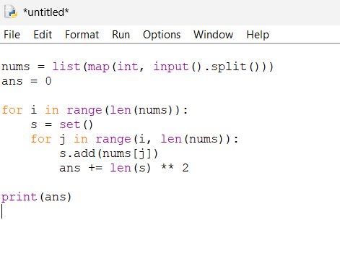
Output:
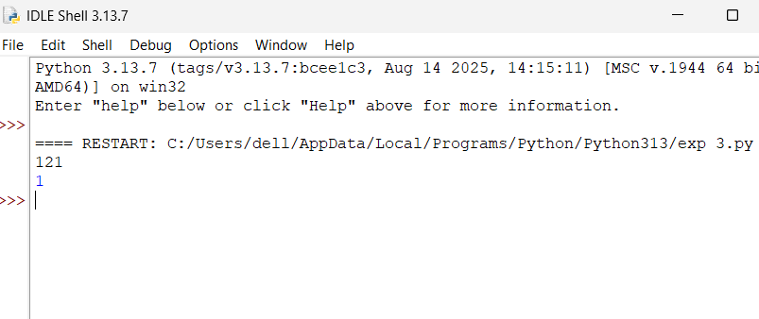

Complexity:
- Time: \(O(n^2)\) expected, using a set with average \(O(1)\) insertion.
- Space: \(O(n)\) for the set.

- Count Equal Pairs Whose Index Product Is Divisible by k

Aim: To count pairs \((i,j)\) such that \(i<j\), nums[i] == nums[j], and i*j is divisible by k.

Pseudocode:
- Start.
- Read the array and integer k.
- Initialize the pair count to zero.
- Check every pair of indices \(i<j\).
- If their values are equal and their index product is divisible by k, increment the count.
- Print the count.
- Stop.

Code:
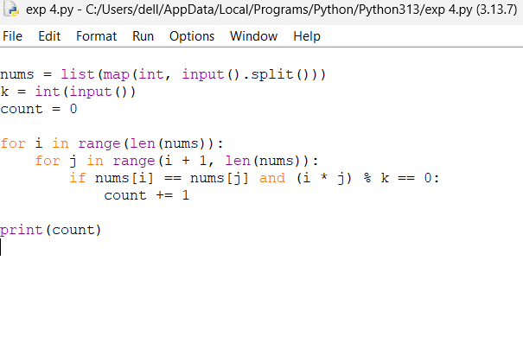
Output:
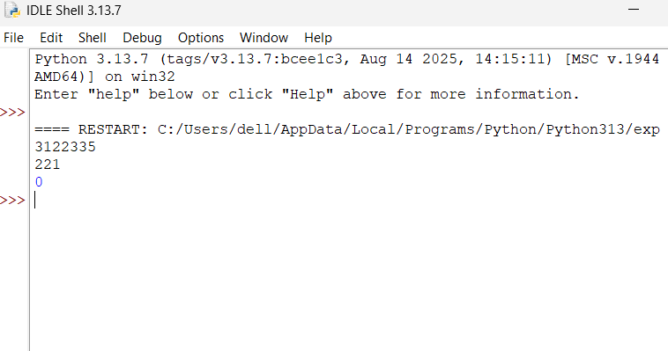

Complexity:
- Time: \(O(n^2)\).
- Space: \(O(1)\) auxiliary space, excluding input storage.

- Find the Maximum Element in an Array

Aim: To find the largest element in an array using minimum time complexity.
Pseudocode:
- Start.
- Read the array.
- If the array is empty, print an appropriate message.
- Assume the first element is the maximum.
- Compare every remaining element with the maximum and update it when necessary.
- Print the maximum element.
- Stop.

Code:
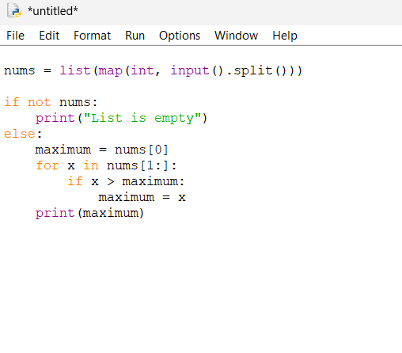
Output:
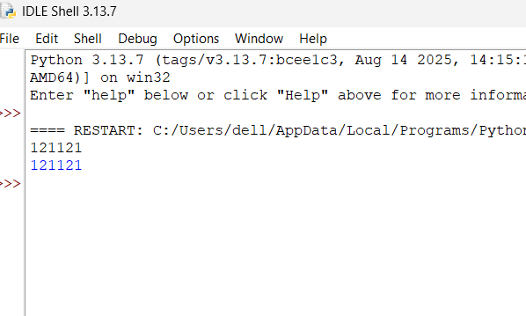

Complexity:
- Time: \(O(n)\), because every element is checked once.
- Space: \(O(1)\) auxiliary space.

- Sort the List and Find the Maximum Element

Aim: To sort a list in ascending order using an efficient sorting algorithm and obtain its maximum element.

Pseudocode:
- Start.
- Read the list.
- If the list is empty, print an empty-list message.
- Sort the list in ascending order.
- Select the last element.
- Print the maximum element.
- Stop.
Code:
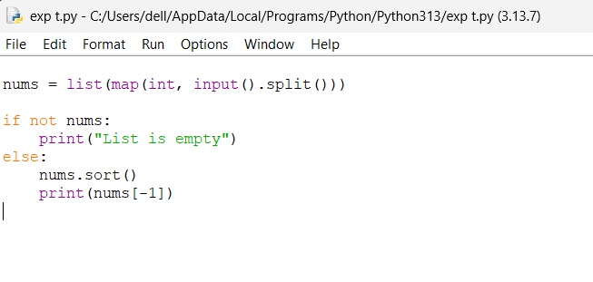
Output:
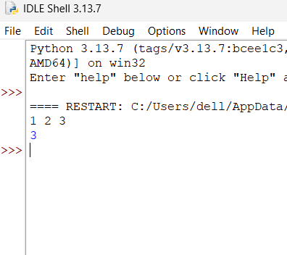

Complexity:
- Time: \(O(n\log n)\) for sorting.
- Space: \(O(n)\) auxiliary space in the general case for Python's sorting implementation.

7.Remove Duplicate Elements from a List
Aim: To create a new list containing each element of the original list only once while preserving its original order.

Pseudocode:
- Start.
- Read the list.
- Create an empty result list and a set.
- Visit every element in the input list.
- If the element is not in the set, add it to the set and result list.
- Print the result list.
- Stop.

Code:
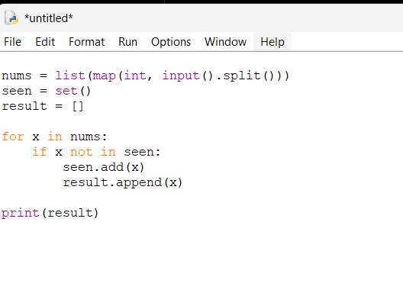
Output:
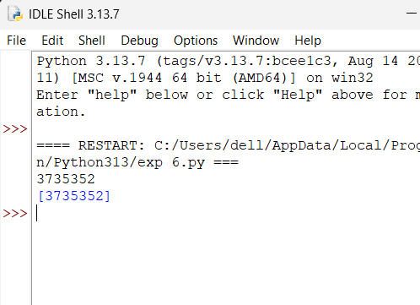
Complexity:
- Time: \(O(n)\) expected, using a set.
- Space: \(O(n)\), because the set and result list may store up to \(n\) distinct elements.

- Bubble Sort

Aim: To sort an array of integers in ascending order using the bubble sort technique.

Pseudocode:
- Start.
- Read the array.
- Compare adjacent elements.
- Swap them if they are in the wrong order.
- Repeat the passes until the array is sorted or no swaps occur.
- Print the sorted array.
- Stop.

Code:
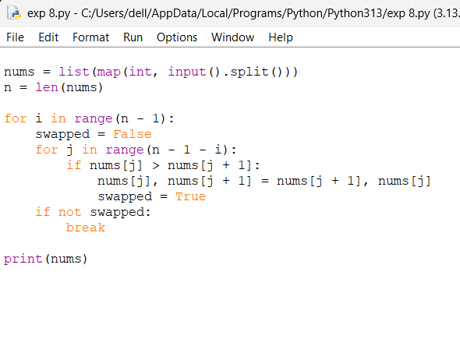

Output:
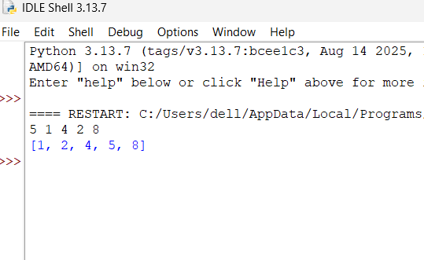
Complexity:
- Best-case time: \(O(n)\), when the array is already sorted.
- Average-case time: \(O(n^2)\).
- Worst-case time: \(O(n^2)\).
- Space: \(O(1)\) auxiliary space.

- Binary Search

Aim: To find the position of a key in a sorted array using binary search.

Pseudocode:
- Start.
- Read the sorted array and the key.
- Set low = 0 and high = n - 1.
- Find the middle index.
- If the middle element equals the key, print its position.
- If the key is greater, search the right half; otherwise, search the left half.
- If the search range becomes empty, print that the element was not found.
- Stop.

Code:
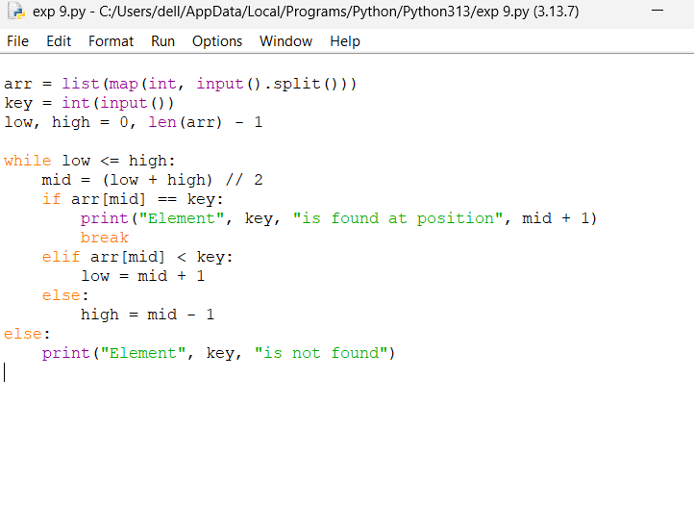
Output:
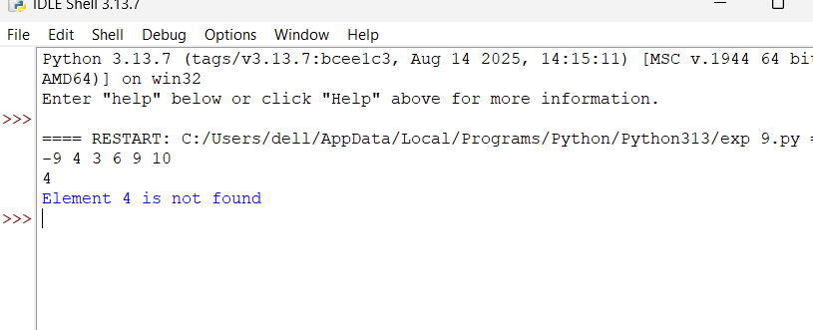
Complexity:
- Time: \(O(\log n)\).
- Space: \(O(1)\) auxiliary space for iterative binary search.

10.Sort an Array in Ascending Order Without Built-in Functions

Aim: To sort an array in ascending order without using built-in sorting functions, achieving \(O(n\log n)\) time and \(O(1)\) auxiliary space.

Pseudocode:
- Start.
- Read the array.
- Build a max heap.
- Swap the root (maximum element) with the last element.
- Reduce the heap size and restore the max heap.
- Repeat until the array is sorted.
- Print the sorted array.
- Stop.

Code:
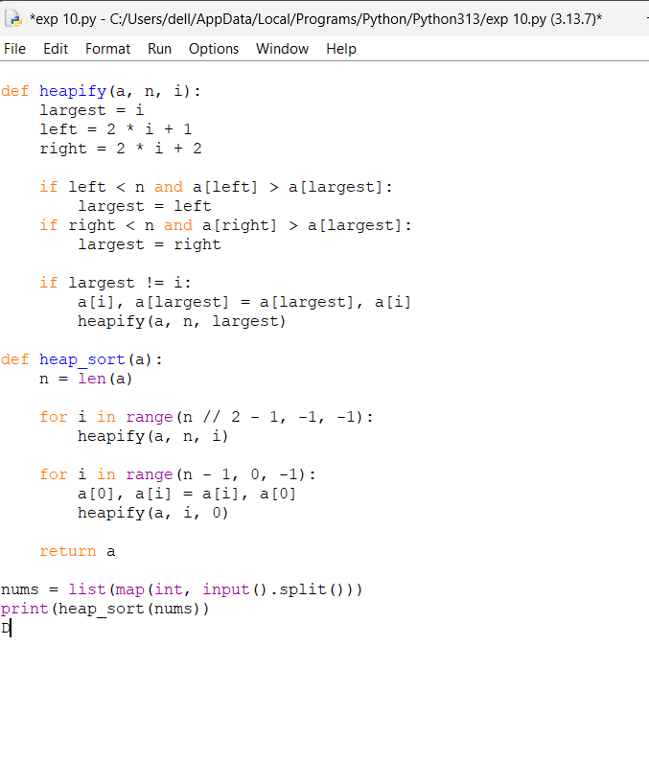

Output:
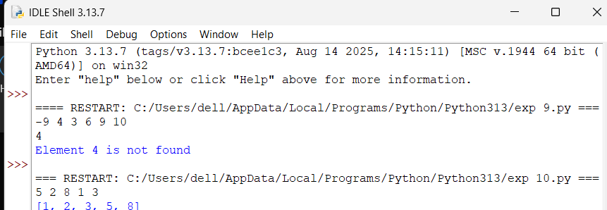

Complexity:
- Time: \(O(n\log n)\) in best, average, and worst cases.
- Space: \(O(\log n)\) for the recursive heapify call stack in the worst case. An iterative heapify implementation can achieve \(O(1)\) auxiliary space.

